**CLASS DIAGRAM:**

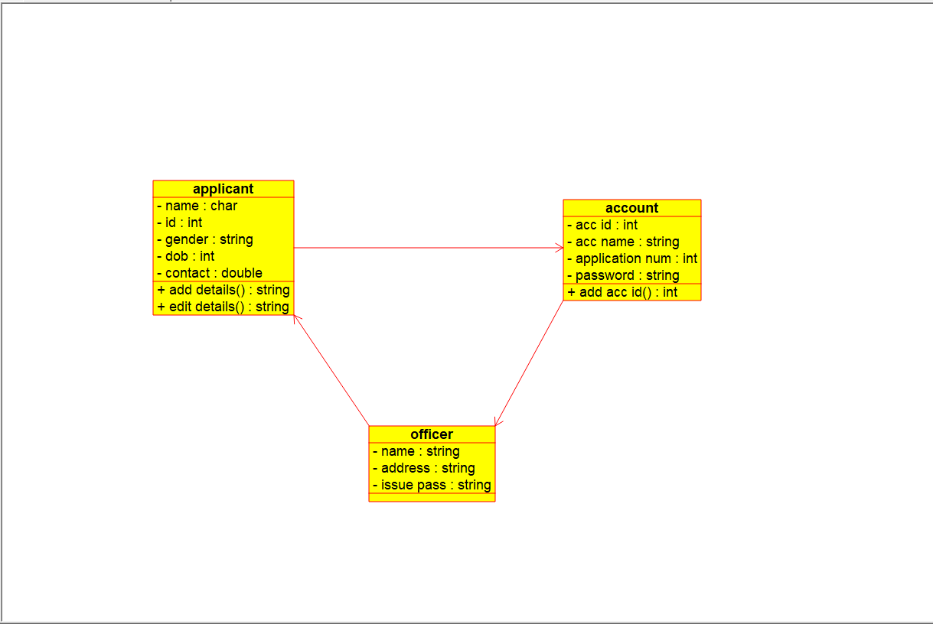

**USE-CASE DIAGRAM:**

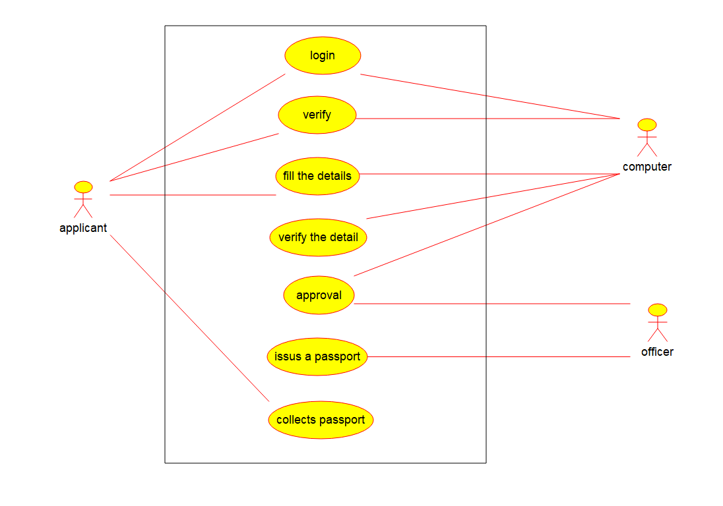

**ACTIVITY DIAGRAM:**

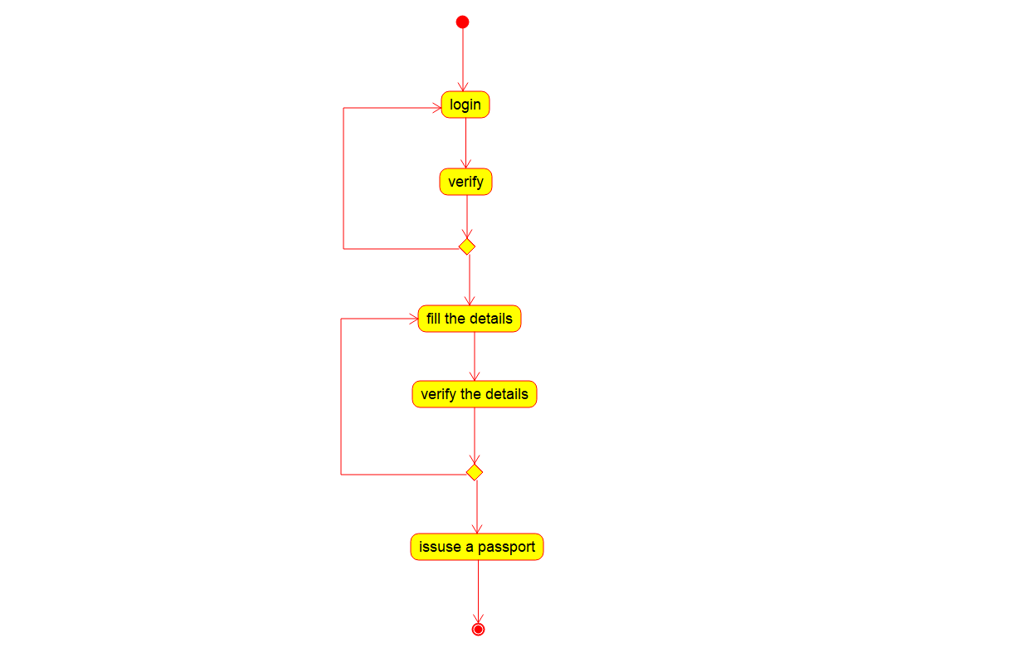

**SEQUENCE DIAGRAM:**

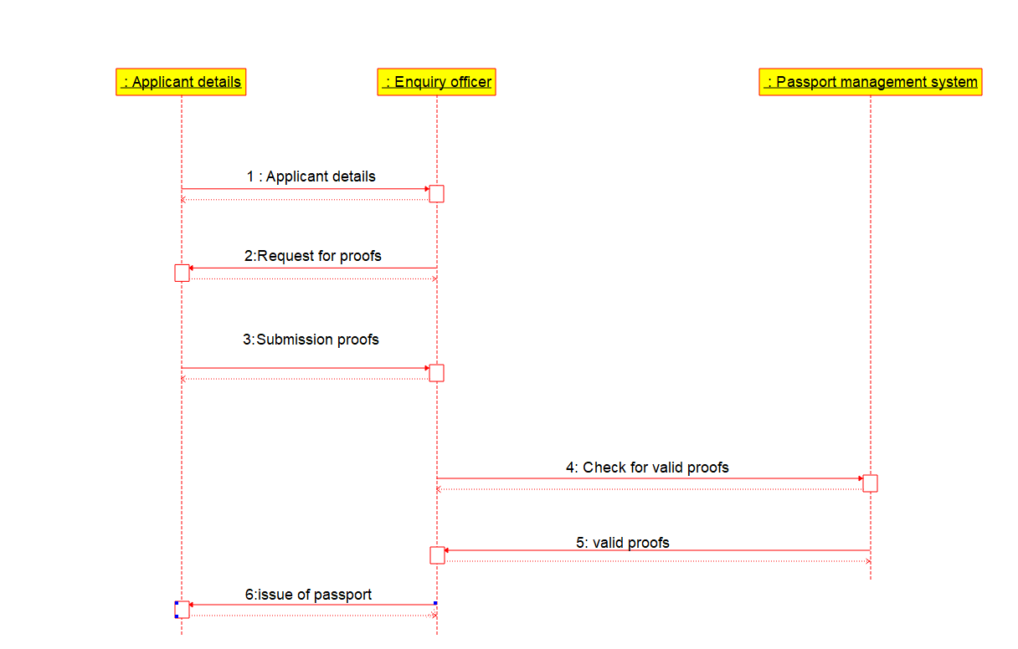

**COLLABORATION DIAGRAM:**

